# Intraspecific variability in germination responses of water-limited alpine/High Mediterranean Mountains environments.

Abstract

## 1. Introduction

Intraspecific variability plays a key role in determining a wide range of biological processes, from individual fitness to population dynamics, species interactions, community assembly and ecosystem properties (detailed review in Westerband et al. 2021). Intraspecific variation has been hypothesized to be a response to highly variable and heterogeneous environments (e.g. Van Kleunen & Fischer 2005). It is an indispensable condition for plants to adjust to novel environmental conditions (e.g. Jump et al. 2009). The adjustment primarily comes from two non-exclusive mechanisms: (1) the development of local adaptations (i.e. adaptive evolution) and (2) the unfolding of phenotypic plasticity (i.e. acclimatisation) (Nicotra et al. 2010; Reed et al. 2011). Adaptive evolution is a transgenerational and long-term process that widens the species’ potential niche (ref, Darwin?). Nevertheless, each locally adapted population has limited conditions in which they can survive, thus becoming more sensible to local threats if dispersal and gene flow are limited (Atkins & Travis 2010; Valladares et al. 2014) and more susceptible under the current climate change (Peterson et al. 2018). In this situation, phenotypic plasticity may be the key to quick plant responses to new conditions (Matesanz et al. 2010; Nicotra et al. 2010; Reed et al. 2011; Walck et al. 2011) and can also act as a buffer to environmental changes (Lande 2009; Chevin et al. 2010).

In recent years, the importance of the seed regeneration niche and its integration within vegetation ecology has become more evident (Larson & Funk 2016; Jiménez-Alfaro et al. 2016). Considering the ample intraspecific variability found in seed traits (Cochrane, Yates, et al. 2015), successful seed reproduction will determine if a species will be able to persist (Fernández-Pascual et al. 2019) while adaption or acclimatization processes are potentially taking place. There is a consensus that temperature and moisture are the main abiotic factors driving seed germination (Baskin & Baskin 2014). Thus, integrating temperature and water availability is a standard and useful approach (i.e. hydrothermal time) to characterize the germination niche (Bradford 2002; Allen et al. 2009; Bewley et al. 2013). For germination to happen temperatures must remain within certain thresholds and water availability must surpass a specific level (i.e. base water potential, ψb) (Baskin & Baskin 2014). Low water availability inhibits several physiological processes that lead to delayed or even impeded germination (Baskin & Baskin 2014). Compared to temperature, few studies have tackled how wild species germination responds to water stress (Bernau et al. 2020; Sumner & Venn 2021). Most information about drought effects on germination comes from studies on arid ecosystems (Yi et al. 2019; Gelviz-Gelvez et al. 2020); in those investigations, responses vary notably depending on species own trade-offs (Kos & Poschlod 2008) and even within species (Yi et al. 2019).

The alpine environment is specially threatened by global warming. International records show higher temperature increasing rates (REF) that could potentially disrupt biological processes like plant phenology (Fernández-Pascual et al. 2019) and germination (Probert 2000; Walck et al. 2011). The high topographic complexity observed at fine scales (Scherrer & Körner 2011) that allows a mosaic of microclimatic conditions (Körner 2021) with sharp gradients within few centimetres (Graham et al. 2012) has been seen to partially buffer climate warming increases (Körner & Hiltbrunner 2021) through communities shifting distributions (paper picos 2024 JVA). Nevertheless, the effects derived of unpredictable precipitation and earlier snowmelt, which could result in water stress during summer (IPCC 2014) still need to be assessed in these areas. Alpine germination studies have been mostly focused on the effect of temperature/warming on germination (e.g. Mondoni et al. 2012; Hoyle et al. 2015; Fernández-Pascual et al. 2021) as moisture is not considered a limiting factor (Ref) in the temperate regions. However, recent research showed that germination is specifically triggered by high soil moisture (Rosbakh et al. 2022). To study the effects of water stress in germination, which are likely to extent in the near future, the High Mediterranean mountains are an ideal example of alpine areas with a two-month drought period in summer (Sumner & Venn 2021) and results differ from the ones obtained in alpine temperate regions (Cochrane et al. 2014). Another limitation of alpine germination studies is that they are mostly focused on population and community levels (e.g. Cavieres & Arroyo 2000; Shimono & Kudo 2005; Wagner & Simons 2009). Very few studies have investigated responses variation at subpopulation level (Gya et al. 2023) and even less have considered the mosaic of microclimatic conditions at fine scales (Scherrer & Körner 2011). In Mediterranean high mountains previous studies have found a particular germination syndrome where seeds can rapidly germinate if water is available (Giménez-Benavides et al. 2005; Giménez-Benavides et al. 2018) but also show some level of seed dormancy that can be alleviated after a chilling and/or an after ripening period (ref).

Here we aim to tackle two understudied topics: (1) germination responses in water-limited alpine High Mediterranean Mountains considering (2) the intraspecific variability of germination responses to water stress at the microscale level. Our focus species in a wild carnation, *Dianthus langeanus* Wilk. (Caryophyllaceae), characteristic of acidic alpine grasslands communities of Iberian Mediterranean mountains. The specific research questions are: (1) Will seeds from warmer (i.e. thus drier) subpopulations germinate better under higher water stress levels (i.e. lower water potentials)? To calculate hydrotime models we need non-dormant seeds, however, no previous studies (to our knowledge) kave specifically addressed dormancy alleviation requirements in our focus species. Thus a second question arises that needs to be answered first (2) Does the seeds' storage time (fresh vs. after ripened seeds) modify their response to water stress? We hypothesize that we will not find germination differences between storage treatment (results: NO, fresh seeds have higher variability of germination responses and germinate worse) and that seeds from warmer/drier subpopulations will germinate better and faster at higher levels of water stress (results YES). To test our hypothesis, we conducted a growth chamber experiment to investigate subpopulation-level intraspecific variation of germination to water stress. The results can help us understand how germination will respond to future climate change scenarios in alpine habitats where precipitation is expected to become more unpredictable (IPCC 2014).

## 2. Methods

### 2.1. Study system

*D. langeanus* Wilk. (Caryophyllaceae) is a wild carnation endemic to the mountain systems of the northwestern Iberian Peninsula (shadowed area in Fig 1A, adapted from Rocha et al 2017). *D. langeanus* Wilk (Caryophyllaceae) mainly lives in open dry grasslands on acid soils (Fig 1B), where it can be locally abundant. Previous experiments indicate flowering onset in early June (Fig 1C), and ripe seeds are dispersed during August. It has high seed production usually >10 seeds per capsule and up to 250 seeds per individual (own field data collected). Germination occurs mainly during end-summer/early autumn at high rates and with high success when water is available at temperatures ranges of 10 – 22 ºC (move along paper). We studied wild populations of *D. langeanus* in the northern limit of its distribution, in the Valles de Omaña and Luna Biosphere Reserve, in the southern ranges of the Cantabrian Mountains (Fig 1A, red square). The Cantabrian Mountains run E-W in northern Spain along 480 km in parallel to the Cantabrian Sea …. This mountain hub encloses summits above 2,500 m a.s.l and the treeline in acids soil climbs up to 1650m a.s.l (ref TFM Jorge). It is considered a transitional biogeographical hub between the Eurosiberian and Mediterranean regions (Jiménez-Alfaro et al. 2021), influenced by Mediterranean climate on the southern slopes and temperate climate on the northern slopes.

### 2.2. Field sites

We established a systematic sampling across four summits above 2000 m a.s.l. (Fig 2 upper panel) inside the distribution area of *D. langeanus* all located above acidic bedrock (soil pH 3.8 – 4.8, own data). In each summit where *D. langeanus* was highly abundant we established a central representative plot (3m radius) where we did a floristic inventory and buried, at 5 cm deep, a Microlog SP3 datalogger, with hourly records of soil temperature and water potential (datalogger MicroLog SP3, EMS Brno, Czech Republic; accuracy in temperature measurements: +/- 0.3 ºC from -40 ºC to 60 ºC; water potential measurements with two Delmhorst gypsum sensors measuring range from -0.1 to -15 bars (permanent wilting point); records every hour). The recording period for the Microlog SP3 went from June 2021 and is currently ongoing. To measure the spatial microenvironmental gradients we then established 20 additional plots (1m2) per each summit. Five plots in each cardinal direction with a 10 m separation (cross design, Fig 2 lower panels). Here, we also did floristic inventories and buried, at 5 cm deep, iButton dataloggers (Thermochron, iButton, Newbury, UK; accuracy: +/- 0.5 ºC from -10 ºC to +65 ºC, resolution: 0.5 ºC, records every four hours). The recording period for the iButtons went from 12 July 2021 to 29 May 2022 (321 days). In total, we collected floristic data from 84 plots and environmental data from 78 plots (one MicroLog SP3 in Cañada was damaged, and 5 iButtons could not be recovered).

*D. langeanus* was present in 47 out of 84 plots (Fig 2 lower panels, coloured diamonds). In the subpopulations where *D. langeanus* was present, local community richness ranged from 3 to 14 species (average of 8 species). *D. langeanus* communities were dominated by Hemicryptophytes (*Festuca summilusitana* Franco and Rocha Afonso, (Poaceae); and *Luzula caespitosa* J. Gay ex E. Mey. Steud, (Juncaceae) and the most frequent accompanying species were (*F. summilusitana*, *L. caespitosa*, *Sedum brevifolium* DC, *Neoschischkinia truncatula* subsp. *durieui* Boiss. & Reut. ex Willk. Valdés & H.Scholz and *Armeria duriaei* Boiss). Soil climate was typically Mediterranean, with a 2-month drought period in summer (Fig 3A, grey bars representing soil water potential). The growing season stretched from April to November with a mean annual soil temperature of 8 ºC. Monthly maximum and minimum soil temperatures reached up to 40 ºC in summer and went down to -4 ºC in winter (Fig 3A, red lines). ADD days with water stress in the growing season and mean of days with snow (high variations according to orientation of slope). To confirm previous literature reports which state that warmer soils also become drier, we took our temperatures measures (transformed as growing degree days, see details in 2.3 microclimatic indices) and plotted it against the accumulative water potentials values at the subpopulation level. We used Microlog SP3 data collected for our four summits in 2022 and 2023 to test if, as expected, there was a positive relationship between GDD and water potential (ΣΨ, R2=0.69, Fig 3B) i.e. warmer years are also drier years.

### 2.3. Microclimatic indices

We used the records of our dataloggers to calculate soil microclimatic indices as in Paper picos. For comparison, we homogenized the data between the two data loggers (MicroLog SP3 and iButtons) by keeping the same recording frequency (every four hours) and the time period with records for all loggers (the 321 calendar days from 12 July 2021 to 29 May 2022). We calculated bioclimatic indices based on WorldClim standard bioclimatic variables (Fick & Hijmans 2017), together with other variables relevant for describing alpine micro topographical gradients. We selected 6 temperature-related indices: (1) bio1 = annual mean temperature; (2) bio2 = mean diurnal range, i.e. the mean of the monthly differences between maximum and minimum temperatures; (3) bio7 = temperature annual range; i.e. the difference between the maximum temperature of the warmest month and the minimum temperature of the coldest month; (4) snow = the number of days of snow cover, when the soil temperature is around 0 ºC, calculated for the period in which the maximum temperature was < 0.5 ºC and the minimum temperature was > -0.5 ºC; (5) FDD = freezing degree days, i.e. the sum of daily mean temperatures for days in which the mean temperature was below 0 ºC (Choler 2018); and (6) GDD = growing degree days, i.e. the sum of daily mean temperatures for days in which the soil mean temperature at five cm deep was above 5 ºC (Körner 2021). For easier interpretation of FDD, we transformed the values from negative to positive, so higher values represent more freezing. To identify the main gradients of microclimatic variability, we conducted a principal component analysis (PCA) including all bioclimatic indices (Fig 3C). Axis 1 of the PCA explained 64% of the variance and ordered the 78 plots along a gradient of thermicity, towards which the greatest contribution was made by GDD (23.4) and bio1 (23.5). GDD was highly correlated with bio1, bio2 and bio7 (> 70%, details in Supplementary xxx) thus, we decided to use GDD as the single best descriptor of microclimatic variability for further analyses.

### 2.4. Seed collection

We sampled seeds of *D. langeanus* from each plot where the species was present (Fig 2 lower panels). We collected mature fruits (capsules) at the time of natural dispersal (August 7-8th, 2023). In each subpopulation, within a 2m radius from the datalogger, we sampled at least 20 randomly selected mother plants following standard protocols for sampling seeds of wild populations (ENSCONET, 2009). In total, we sampled 47 plots with *D. langeanus* but only were able to collect enough seeds for experiments (> 600 seeds) from 18 of them, hereafter called “subpopulations”. Immediately after collection, we manually cleaned the seeds and kept them at room conditions (22 ºC and 35 % RH) until the start of the germination experiments. For each subpopulation used in subsequent experiments, we measured dry seed mass by weighing 10 individual seeds from each subpopulation after the seeds had spent 3 months drying with silica gel (Mettler Toledo, New classic SG – Model ML1052E/01, precision 0.1 mg). We did not find previous information about the species' water requirements for germination. Consequently, we tested it across a large gradient of water potential to identify the base water potential required for germination.

### 2.5. Germination experiments

We wanted to measure germination responses to water stress in functionally significant ecological conditions, i.e. using fresh seeds at the time of dispersal. However, although our previous experiments indicated high germination in relatively fresh *D. langeanus* seeds, we also expected that the seeds could show some light level of physiological dormancy and that they could require dry after-ripening to release this dormancy, as mentioned above. Since we wanted to calculate hydro-time models, and these models require working with non-dormant seed lots, we decided to repeat the experiments with two seed storage treatments: fresh seeds (10 days after collection, hereafter called “fresh”) and after ripened seeds (45 days after collection, hereafter called “after ripened”). For each storage treatment, we used 12 subpopulations, as seed numbers allowed: 6 subpopulations were repeated for both treatments, 6 subpopulations were used only for the fresh treatment, and 6 subpopulations were used only for the after ripened treatment (Table 1).

To test the seed germination responses to water stress, we performed laboratory experiments using polyethylene glycol (PEG, an inert water-binding polymer) solutions to simulate different water potential scenarios. PEG solutions maintain relatively steady and precise the desired osmotic potentials to study germination thresholds (ref). Since we could not find previous information about the species water potential requirements for germination, we performed a previous pilot study that showed zero germination at -1.4 and -1.6 MPa. Thus, we excluded those levels and selected seven water potential treatments for the final experiment: 0, −0.2, −0.4, −0.6, −0.8, −1 and −1.2 MPa. For each treatment combination (7 water potential treatments x 2 storage treatments x 12 subpopulations) we sowed four Petri dishes with 25 seeds each (except in the -1 and -1.2 MPa water potential treatments, where we expected low germination, and we sowed only 2 dishes with 25 seeds each). We used 90 mm Ø Petri dishes with two layers of filter paper (Filtros Anoia S.A. paper for germination assays, Ref.518G085). To each dish, we added 5 ml of either (a) distilled water or (b) a PEG 6000 solution prepared according to Michel & Kaufmann (1973) and (Villela et al. 1991) to reach desired osmotic potentials at 20 ºC (the experimental temperature). We sealed Petri dishes with parafilm to avoid evaporation of the solutions and to maintain constant water potentials throughout the experiment.

Seeds were incubated in conditions simulating late summer days in the field, when germination has been seen to happen (paper move-along): constant 20°C with a daily photoperiod of 12-12h light/dark. It must be noted that we used constant 20ºC rather than a more realistic diurnal alternating regime in order to maintain the stability of water stress conditions for the PEG solutions. Conditions were programmed in an incubator (Aralab climatic chamber Fitoclima S600 PL, equipped with four led modules 11W 350mA). We monitored germination, defined as radicle emergence > 1.5mm, for 28 days: daily until the cumulative germination curve flattened (day 21) and then every two or three days until the end of the experiment. We removed germinated seeds during the scoring and, once the experiments were finished, we cut non-germinated seeds under a binocular loupe and classified them as viable, dead or empty. Seeds with firm and white embryos were considered viable, i.e. potentially germinable (Baskin and Baskin 2014). Subsequent analyses only consider germinated and germinable seeds. A total of xxxx viable (germinated + germinable) *D. langeanus* seeds were used in this study.

### 2.6. Data analysis

### All analyses were done in R (R Core Team 2022) using the packages glmmTMB (Brooks et al. 2017) or fitting Generalized Linear Mixed Models (GLMMs) and seedr (Fernández-Pascual & González-Rodríguez 2020) for fitting hydro time models. Model fit and residuals were visually checked using the DHARMa package (Hartig 2020). Data visualization was created with packages ggplot2 (Wickham 2016) and patchwork (Pedersen 2023) with the wesanderson palette (Ram & Wickham 2023).

To test if final germination varied as a function of water potential and storage time, we fitted GLMMs with binomial distribution. Final germination proportion was the response variable. Explanatory fixed factors were the storage and water potential treatments. Random factors included subpopulation nested within summit. Model formula: Final germination (germinated, viable - germinated) ~ storage * water potential + (1|summit/subpopulation), family = binomial. To calculate the water potential germination thresholds of each subpopulation, we fitted hydrotime models with seedr package. For each subpopulation, the model returned the base water potential (ψb), i.e. the lower water potential threshold beyond which no germination is possible. Then, we modelled base water potential as a function of the subpopulation’s microclimate (measured as GDD, see above) using GLMMs with Gaussian distribution. Explanatory fixed factors were the storage treatment and the subpopulation’s specific GDD. The summit was included as a random factor (and not subpopulation, as before, since in this case each subpopulation provided one data point for the model). Model formula: ψb ~ storage * GDD + (1|summit), family = Gaussian. We found a significant interaction storage * GDD, consequently, we tested each storage treatment separately to check if base water potential varied according to GDD in fresh and after ripened seeds. Model specification: ψb ~ GDD + (1|summit), family = Gaussian.

Additionally, we checked if base water potential varied as a function of seed mass by fitting GLMMs with gamma distribution (since the model did not fulfil Gaussian assumptions). Base water potential was used as the response variable and seed mass and storage treatment as the explanatory variables. Summit was included as a random factor. Model formula: ψb ~ seed weight * storage + (1|summit), family = Gamma. We did find a marginally significant relationship when both storage treatments were analysed separately: only in after ripened seeds we found a marginally significant negative relationship i.e. the heavier the seed the lower the base water potential for germination (details in Supplementary xxx).

## 3. Results

### 3.1 Effect of storage treatment and water potential on final germination proportions

Final germination was higher in after ripened than in fresh seeds (Fig 4A). With no water stress (i.e. distilled water treatment, WP treatment = 0) fresh seeds only attained around 70% germination, while germination of after ripened seeds was almost 100%. With increasing water stress, germination dropped below 50% at -0.2 MPa in fresh seeds, whereas, in after ripened seeds water stress needed to reach -0.6 MPa to cross the same germination threshold. At -0.8 MPa and below, germination was negligible in both fresh and after ripened seeds. Lower water potential also led to slower germination (Fig 4B). GLMMs confirmed that differences between storage and water potential treatments were statistically significant (p-value < 0.001 in both explanatory fixed factors and significant interaction, Supplementary table xx).

### 3.2 Germination base water potential as a function of microclimate

We used Bradford’s hydrotime model to calculate the ψb for germination for the 12 subpopulations in the fresh treatment and the 12 populations in the after ripened treatment (Table 1). Values of ψb were higher (i.e. less water stress-tolerant) in the fresh than in the after ripened seeds (average -0.1 vs -0.4 in those 6 subpopulations that were sown at both storage times) (Table 1). Given the significant interaction between storage treatment and microclimate (measured as GDD; model z = 2.45, p-value < 0.05), we analysed the relationship between base water potential and GDD separately for fresh and after ripened seeds. For fresh seeds we found no significant relationship (Fig 4 left panel). On the contrary, after ripened seeds showed a significant relationship (z = -1.99, p-value <0.05) of decreasing ψb in subpopulations with higher GDD (Fig 4, right panel).

### 4. Discussion

Our study shows that wild populations of *D. langeanus* have significant subpopulation variation in germination responses to water stress at microscale level, corroborating our hypothesis. Although intraspecific trait variation has been previously stated to be strongly driven by microenvironmental heterogeneity (Westerband 2021, add reference); to our knowledge, is the first time that subpopulation variation at microscale level for regeneration traits has been reported in alpine areas.

P1: Interpretate main results answering our questions

The higher germination we observed in after-ripened seeds across all water potential treatments confirms a low level of dormancy in fresh *D. langeanus* seeds that was efficiently alleviated by a short period of after-ripening (35 days). Against our initial expectation, seeds completely changed their germination responses in a month difference, suggesting notable ecological implications of the rainfall timing in alpine water-limited environments. If rain episodes occur just after seeds dispersal overall reproductive success will be hindered by the chaotic response probably due to dormancy or “immaturity” that led to an incorrect interpretation of the environmental cues (ref). If rain episodes happen later, when seeds are able to respond appropriately to soil water stress, reproductive success will be notably higher.

The lower base water potential observed in after ripened seeds (i.e. ability to germinate with less water available) was significantly higher in subpopulations from warmer microclimatic conditions. This observation suggests either a potential local adaptation or a wide phenotypic plasticity even at microscale (some subpopulations were only 10 m apart). In the treatments with lower water potential we could also observe a germination delay, confirming results reported by (Cochrane, Hoyle, et al. 2015; Gya et al. 2023) Vázquez-Ramírez and Venn 2021,). These studies suggest a bet-hedging strategy to spread the risk of non-successful germination across a wider time period “waiting” for an water input Simons, 2011; Venable, 2007). This strategy has been observed in other habitats with high climate variability and advantageous during drought events (Evans and Dennehy, 2005, Lampei et al 2017).

P2: Relate interpretation of the results with literature.

Our results highlight how important a short after ripening period (30 days) can have a major impact in seeds responses in the field. Therefore, future scenarios with unpredictable rainfall (ref) could lead to years with unsuccessful reproduction by seeds. Consequently, other seed traits like soil seed bank persistence (ref) will become key for maintaining successful populations with high genetic variation. Nevertheless, we should be careful when comparing laboratory results obtained by PEG solutions to field behaviours. In the field, soil water availability seems to be more related to soil hydraulic conductivity, which in turn depends on soil textural properties (Camacho et al. 2021).

The obtained intraspecific variation in base water potential values, demonstrates the importance of water availability in oromediterraneous germination, which has not been considered in previous alpine grassland research (ref) and will become more incident in the future. Unexpectedly, *D. langeanus* germinate under relatively low water stress (i.e. germination seems not tolerant to water stress) thus its germination phenology and rapid response to environmental cues related to water inputs appears to be key for a successful regeneration. The base water potential for *D. langeanus* (-0.6 MPa) is comparable to other studies in Britain where a sharp decrease in germination with water potentials between -0.57 and -0.7 MPa (Evans and Etherington (1990). Cochrane 2014 (decline in germination greatest between 0 and –0.25 MPa)

Studying narrow endemic species is advantageous because biogeographical and historical influences are not substantial, and local adaptation can be assumed to take place in situ along the environmental gradient (Fernández-Pascual et al. 2013). However, it must be taken into account, that the intraspecific variation we detected in this study cannot be attributed solely to local adaptation. The persistence of populations is shaped by a dynamic and complex feedback between phenotypic plasticity and local adaptation (Kinnison & Hairston 2007) however previous studies showed that adaptive evolution of phenotypic plasticity is possible in nature, even at small spatial scales (van Keunen 2005, add reference). To disentangle their effects, reciprocal and common garden experiments are needed (e.g., Potvin & Tousignant 1996). Nevertheless, what is clear is that subpopulation differences in our study area do not follow a random pattern. This is in line with several studies in alpine areas which suggest that local adaptation processes are taking place in the seed regeneration niche (Giménez-Benavides et al., 2007; Kim & Donohue, 2013; Mondoni et al., 2009). Other investigations showed local adaptation where seeds from drier ecotones had a slower and lower germination than landraces from wetter environments (Bernau et al. 2020), in opposition to our results where seed from drier/warmer subpopulations had a faster and higher germination.

Seed mass has been previously studied in association with responses to drought. Nevertheless, there are contradictory evidences: some studies found that small seeds responded better to water stress (Kikuzawa &Koyoma 1999, Merino-Martín et al. (2017, Gya 2023) while others found the opposite results with large seeds being more successful at germination in water stress (Kidson & Westoby (2000, (Gelviz-Gelvez et al. 2020) or even no differences (Yi et al. 2019; Gya et al. 2023). Our results in *D. langeanus* indicate differential responses depending on seeds storage time, with fresh seeds no trend was detected but in after ripened seeds, subpopulations with heavier seeds showed lower base water potentials, corroborating results by (Kidson & Westoby (2000, (Gelviz-Gelvez et al. 2020). More research is needed to disentangle if there is a general role of seed size as a response to drought or if is species specific (Gelviz-Gelvez et al. 2020). More investigations are also required to clarify if relationships between seed size and germination under water stress might differ among ecosystems (Yi et al. 2019).

P3: Limitations of the study:

We note that although our study shed new insights into intraspecific germination responses in water limited alpine environments, the conclusions are still preliminary and limited by several conditions. Firstly, our environmental data collection is constrained to 2021- 2022 while seeds were collected in 2023, however we assume that relative differences between subpopulations remain constant across years and it is a valuable indication of the thermicity gradient. In addition, we use two different types of loggers, but when comparing raw data temperature values correlate and thus we consider them comparable. Secondly, we aimed to collect enough seeds from at least 30 subpopulations, nevertheless statistical models still detected significant relationships within our subpopulation data (n = 18). Thirdly, the experimental germination conditions are not realistic in the field, but they were necessary to maintain WP treatments stability. Moreover, previous studies indicate that the focus species has a wide germination niche without significant differences between constant and alternating temperatures, reaching up to 70% germination even in darkness. Although the transfer of laboratory PEG results to field behaviours should be done carefully (Camacho et al. 2021), it must also be considered that field germination experiments are extremely rare. We are currently working to expand our data collection to cover this research gap.

P4: future directions:

Future research in more oromediterranean species can enhance our knowledge on seed regeneration under water stress in alpine habitats and consequently understand possible future changes in community structure (Yi et al. 2019). There is a need for more field-based experiments focusing on the seed regeneration niche, including soil seed persistence and seedling responses to microclimatic conditions. In addition, complementary studies with reciprocal sows and common garden experiments will help us to disentangle the effects of phenological plasticity and to understand the potential of local adaptation to buffer climatic changes.

## 5. References

Allen, P.S., Meyer, S.E., & Khan, M.A. 2009. Hydrothermal time as a tool in comparative germination studies. *Seed biology: advances and applications. Proceedings of the Sixth International Workshop on Seeds, Merida, Mexico, 1999.* 401–410.

Atkins, K.E., & Travis, J.M.J. 2010. Local adaptation and the evolution of species’ ranges under climate change. *Journal of Theoretical Biology* 266: 449–457.

Baskin, C.C., & Baskin, J.M. 2014. *Seeds. Ecology, Biogeography and Evolution of Dormancy and Germination*. Academic Press, San Diego, CA, USA.

Bernau, V.M., Barbolla, L.J., McHale, L.K., & Mercer, K.L. 2020. Germination response of diverse wild and landrace chile peppers (Capsicum spp.) under drought stress simulated with polyethylene glycol. *PLoS ONE* 15: 1–19.

Bewley, J., Bradford, K., Hilhorst, H., & Nonogaki, H. 2013. Environmental regulation of dormancy and germination. In Bewley, J., Bradford, K., & Hilhorst, H. (eds.), *Seeds: physiology of development, germination and dormancy*, Springer, New York.

Bradford, K.J. 2002. Applications of hydrothermal time to quantifying and modeling seed germination and dormancy. *Weed Science* 50: 248–260.

Brooks, M.E., Kristensen, K., Benthem, K.J. van, Magnusson, A., Berg, C.W., Nielsen, A., Skaug, H.J., Maechler, M., & Bolker, B.M. 2017. glmmTMB Balances Speed and Flexibility Among Packages for Zero-inflated Generalized Linear Mixed Modeling. *The R Journal* 9: 378–400.

Camacho, M.E., Heitman, J.L., Gannon, T.W., Amoozegar, A., & Leon, R.G. 2021. Seed germination responses to soil hydraulic conductivity and polyethylene glycol (PEG) osmotic solutions. *Plant and Soil* 462: 175–188.

Cavieres, L.A., & Arroyo, M.T.K. 2000. Seed germination response to cold stratification period and thermal regime in Phacelia secunda (Hydrophyllaceae): Altitudinal variation in the mediterranean Andes of central Chile. *Plant Ecology* 149: 1–8.

Chevin, L.M., Lande, R., & Mace, G.M. 2010. Adaptation, plasticity, and extinction in a changing environment: Towards a predictive theory. *PLoS Biology* 8:.

Cochrane, J.A., Hoyle, G.L., Yates, C.J., Wood, J., & Nicotra, A.B. 2015. Climate warming delays and decreases seedling emergence in a Mediterranean ecosystem. *Oikos* 124: 150–160.

Cochrane, J.A., Hoyle, G.L., Yates, C.J., Wood, J., & Nicotra, A.B. 2014. Evidence of population variation in drought tolerance during seed germination in four Banksia (Proteaceae) species from Western Australia. *Australian Journal of Botany* 62: 481–489.

Cochrane, A., Yates, C.J., Hoyle, G.L., & Nicotra, A.B. 2015. Will among-population variation in seed traits improve the chance of species persistence under climate change? *Global Ecology and Biogeography* 24: 12–24.

Fernández-Pascual, E., Carta, A., Mondoni, A., Cavieres, L.A., Rosbakh, S., Venn, S., Satyanti, A., Guja, L., Briceño, V.F., Vandelook, F., Mattana, E., Saatkamp, A., Bu, H., Sommerville, K., Poschlod, P., Liu, K., Nicotra, A., & Jiménez-Alfaro, B. 2021. The seed germination spectrum of alpine plants: a global meta-analysis. *New Phytologist* 229: 3573–3586.

Fernández-Pascual, E., & González-Rodríguez, G. 2020. seedr: Hydro and Thermal Time Germination Models in R.

Fernández-Pascual, E., Mattana, E., & Pritchard, H.W. 2019. Seeds of future past: climate change and the thermal memory of plant reproductive traits. *Biological Reviews* 94: 439–456.

Gelviz-Gelvez, S.M., Pavón, N.P., Flores, J., Barragán, F., & Paz, H. 2020. Germination of seven species of shrubs in semiarid central Mexico: Effect of drought and seed size. *Botanical Sciences* 98: 464–472.

Giménez-Benavides, L., Escudero, A., García-Camacho, R., García-Fernández, A., Iriondo, J.M., Lara-Romero, C., & Morente-López, J. 2018. How does climate change affect regeneration of Mediterranean high-mountain plants? An integration and synthesis of current knowledge. *Plant Biology* 20: 50–62.

Giménez-Benavides, L., Escudero, A., & Pérez-García, F. 2005. Seed germination of high mountain Mediterranean species: Altitudinal, interpopulation and interannual variability. *Ecological Research* 20: 433–444.

Graham, E., Rundel, P., Kaiser, W., Lam, Y., Stealey, M., & Yuen, E. 2012. Fine-scale patterns of soil and plant surface temperatures in an alpine fellfield habitat, white mountains, California. *Arctic, Antarctic, and Alpine Research* 44: 288–295.

Gya, R., Geange, S.R., Lynn, J.S., Töpper, J.P., Wallevik, Ø., Zernichow, C., & Vandvik, V. 2023. A test of local adaptation to drought in germination and seedling traits in populations of two alpine forbs across a 2000 mm/year precipitation gradient. *Ecology and Evolution* 13: 1–19.

Hartig, F. 2020. DHARMa: Residual Diagnostics for Hierarchical (Multi-Level / Mixed) Regression Models.

Hoyle, G.L., Steadman, K.J., Good, R.B., McIntosh, E.J., Galea, L.M.E., & Nicotra, A.B. 2015. Seed germination strategies: An evolutionary trajectory independent of vegetative functional traits. *Frontiers in Plant Science* 6: 1–13.

IPCC. 2014. *Climate change 2014 Synthesis Report*. Geneva, Switzerland.

Jiménez-Alfaro, B., Carlón, L., Fernández-Pascual, E., Acedo, C., Alfaro-Saiz, E., Redondo, R.A., Cires, E., del Egido Mazuelas, F., del Río, S., Díaz-González, T.E., García-González, M.E., Lence, C., Llamas, F., Nava, H., Penas, Á., Rodríguez Guitián, M.A., & Vázquez, V.M. 2021. Checklist of the vascular plants of the Cantabrian Mountains. *Mediterranean Botany* 42: 1–60.

Jiménez-Alfaro, B., Silveira, F.A.O., Fidelis, A., Poschlod, P., & Commander, L.E. 2016. Seed germination traits can contribute better to plant community ecology. *Journal of Vegetation Science* 27: 637–645.

Jump, A.S., Marchant, R., & Peñuelas, J. 2009. Environmental change and the option value of genetic diversity. *Trends in Plant Science* 14: 51–58.

Van Kleunen, M., & Fischer, M. 2005. Constraints on the evolution of adaptive phenotypic plasticity in plants. *New Phytologist* 166: 49–60.

Körner, C. 2021. *Alpine Plant Life* (Springer Nature Switzerland AG 2021, Ed.). Springer Cham.

Körner, C., & Hiltbrunner, E. 2021. Why is the alpine flora comparatively robust against climatic warming? *Diversity* 13:.

Kos, M., & Poschlod, P. 2008. Correlates of inter-specific variation in germination response to water stress in a semi-arid savannah. *Basic and Applied Ecology* 9: 645–652.

Lande, R. 2009. Adaptation to an extraordinary environment by evolution of phenotypic plasticity and genetic assimilation. *Journal of Evolutionary Biology* 22: 1435–1446.

Larson, J.E., & Funk, J.L. 2016. Regeneration: an overlooked aspect of trait-based plant community assembly models. *Journal of Ecology* 104: 1284–1298.

Matesanz, S., Gianoli, E., & Valladares, F. 2010. Global change and the evolution of phenotypic plasticity in plants. *Annals of the New York Academy of Sciences* 1206: 35–55.

Michel, B.E., & Kaufmann, M.R. 1973. The Osmotic Potential of Polyethylene Glycol 60001.

Mondoni, A., Rossi, G., Orsenigo, S., & Probert, R.J. 2012. Climate warming could shift the timing of seed germination in alpine plants. *Annals of Botany* 110: 155–164.

Nicotra, A.B., Atkin, O.K., Bonser, S.P., Davidson, A.M., Finnegan, E.J., Mathesius, U., Poot, P., Purugganan, M.D., Richards, C.L., Valladares, F., & van Kleunen, M. 2010. Plant phenotypic plasticity in a changing climate. *Trends in Plant Science* 15: 684–692.

Pedersen, T.L. 2023. patchwork: The Composer of Plots.

Peterson, M.L., Doak, D.F., & Morris, W.F. 2018. Both life-history plasticity and local adaptation will shape range-wide responses to climate warming in the tundra plant Silene acaulis. *Global Change Biology* 24: 1614–1625.

Probert, R.J. 2000. The role of temperature in the regulation of seed dormancy and germination. In Fenner, M. (ed.), *Seeds: the ecology of regeneration in plant communities*, pp. 261–292. Wallingford, CABI.

R Core Team. 2022. R: A Language and Environment for Statistical Computing.

Ram, K., & Wickham, H. 2023. wesanderson: A Wes Anderson Palette Generator.

Reed, T.E., Schindler, D.E., & Waples, R.S. 2011. Efectos Interactivos de la Plasticidad Fenotípica y Evolucíon sobre la Persistencia Poblacional en un Clima Cambiante. *Conservation Biology* 25: 56–63.

Rosbakh, S., Fernández-Pascual, E., Mondoni, A., & Onipchenko, V. 2022. Alpine plant communities differ in their seed germination requirements along a snowmelt gradient in the Caucasus. *Alpine Botany* 132: 223–232.

Scherrer, D., & Körner, C. 2011. Topographically controlled thermal-habitat differentiation buffers alpine plant diversity against climate warming. *Journal of Biogeography* 38: 406–416.

Shimono, Y., & Kudo, G. 2005. Comparisons of germination traits of alpine plants between fellfield and snowbed habitats. *Ecological Research* 20: 189–197.

Sumner, E., & Venn, S. 2021. Plant responses to changing water supply and availability in high elevation ecosystems: A quantitative systematic review and meta‐analysis. *Land* 10:.

Valladares, F., Matesanz, S., Guilhaumon, F., Araújo, M.B., Balaguer, L., Benito-Garzón, M., Cornwell, W., Gianoli, E., van Kleunen, M., Naya, D.E., Nicotra, A.B., Poorter, H., & Zavala, M.A. 2014. The effects of phenotypic plasticity and local adaptation on forecasts of species range shifts under climate change. *Ecology Letters* 17: 1351–1364.

Villela, F.A., Doni Filho, L., & Sequeira, E.L. 1991. Tabela de potencial osmótico em função da concentração de polietileno glicol 6.000 e da temperatura. *Pesquisa Agropecuária Brasileira* 26: 1957–1968.

Wagner, I., & Simons, A.M. 2009. Divergence in Germination Traits among Arctic and Alpinepopulations of Koenigia islandica: Light Requirements. *Plant Ecology* 204: 145–153.

Walck, J.L., Hidayati, S.N., Dixon, K.W., Thompson, K., & Poschlod, P. 2011. Climate change and plant regeneration from seed. *Global Change Biology* 17: 2145–2161.

Westerband, A.C., Funk, J.L., & Barton, K.E. 2021. Intraspecific trait variation in plants: A renewed focus on its role in ecological processes. *Annals of Botany* 127: 397–410.

Wickham, H. 2016. ggplot2: Elegant Graphics for Data Analysis.

Yi, F., Wang, Z., Baskin, C.C., Baskin, J.M., Ye, R., Sun, H., Zhang, Y., Ye, X., Liu, G., Yang, X., & Huang, Z. 2019. Seed germination responses to seasonal temperature and drought stress are species-specific but not related to seed size in a desert steppe: Implications for effect of climate change on community structure. *Ecology and Evolution* 9: 2149–2159.

Table 1. Bradford hydrotime model results from dr hydrotime function.

|  |  |  |  |  |  |  |  |  |  |  |
| --- | --- | --- | --- | --- | --- | --- | --- | --- | --- | --- |
|  |  | **Fresh** | | | |  | **After ripened** | | | |
| **Sub**  **population** | N treatments | theta | ψb | sigma | R2 | N treatments | theta | ψb | sigma | R2 |
| **A00** | 7 | 0.73 | 0.04 | 0.47 | 0.81 | 4 | 1.03 | -0.40 | 0.17 | 0.97 |
| **A02** |  |  |  |  |  | 5 | 1.50 | -0.55 | 0.24 | 0.96 |
| **A11** |  |  |  |  |  | 5 | 1.18 | -0.44 | 0.27 | 0.98 |
| **B00** | 6 | 0.95 | -0.06 | 0.41 | 0.88 |  |  |  |  |  |
| **B03** | 6 | 1.26 | 0.08 | 0.57 | 0.89 | 5 | 1.46 | -0.47 | 0.25 | 0.95 |
| **B07** | 5 | 0.78 | 0.07 | 0.41 | 0.88 |  |  |  |  |  |
| **B17** | 6 | 1.26 | -0.10 | 0.45 | 0.91 |  |  |  |  |  |
| **B19** |  |  |  |  |  | 4 | 1.09 | -0.35 | 0.25 | 0.96 |
| **B20** | 4 | 0.67 | -0.16 | 0.28 | 0.90 |  |  |  |  |  |
| **C00** | 6 | 0.87 | -0.17 | 0.32 | 0.90 | 5 | 1.14 | -0.43 | 0.22 | 0.95 |
| **C06** | 5 | 0.92 | -0.25 | 0.34 | 0.94 |  |  |  |  |  |
| **C18** |  |  |  |  |  | 5 | 1.09 | -0.37 | 0.24 | 0.95 |
| **C19** | 6 | 0.70 | -0.17 | 0.38 | 0.91 | 6 | 0.92 | -0.41 | 0.24 | 0.94 |
| **C20** |  |  |  |  |  | 5 | 1.20 | -0.44 | 0.23 | 0.94 |
| **D00** | 5 | 0.92 | -0.23 | 0.32 | 0.91 | 5 | 1.01 | -0.45 | 0.21 | 0.93 |
| **D11** |  |  |  |  |  | 5 | 1.54 | -0.48 | 0.30 | 0.90 |
| **D12** | 5 | 0.77 | -0.13 | 0.31 | 0.88 |  |  |  |  |  |
| **D19** | 5 | 0.94 | -0.16 | 0.35 | 0.93 | 5 | 1.29 | -0.42 | 0.28 | 0.91 |

Fig1: (A) Iberian Peninsula map, red square highlights our study system. Shadows show *D. langeanus* potential distribution under current climatic conditions (adapted from Rocha et al., 2017); (B) Picture of high mountains dry grasslands in our study area; (C) *D. langeanus* flower and seed image.

Fig 2. Upper panel: Location of the four summits included in our study. Lower panels: Spatial image of our sampling cross design in each of the four summits, at each square we registered botanical inventories and buried iButtons. Coloured squares represents where *D. langeanus* was present and seeds were collected.

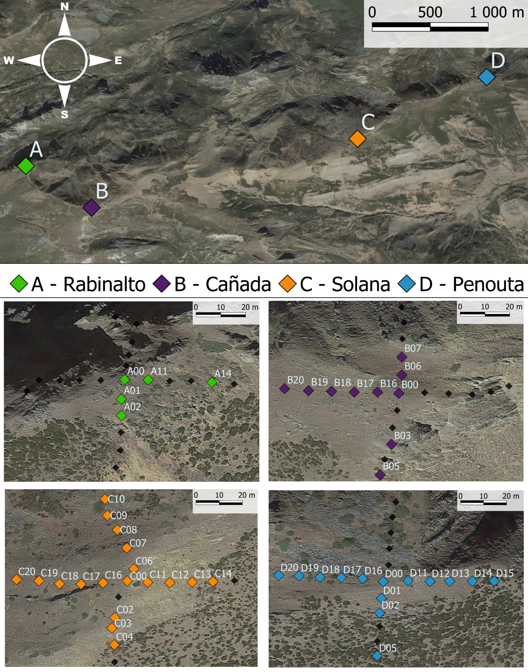

Fig 3. (A) Climogram of our study area, based on Microlog SP3 data from July 2021 to June 2022 from three of the four investigated summits. Lines in red represent monthly mean maximum and minimum temperatures; bars in grey represent the monthly mean of maximum ψb in Mpa. (B) Correlation graph between GDD and absolute sum of ψb registered. We used data from the growing season (April-November) of 2022 and 2023 in three of our summits, Cañada data is not complete and thus was removed from visualization. (C) Principal Component Analysis of all 78 plots with environmental data, filtered according to iButtons recording specifications, each colour represents plots of a different summit.

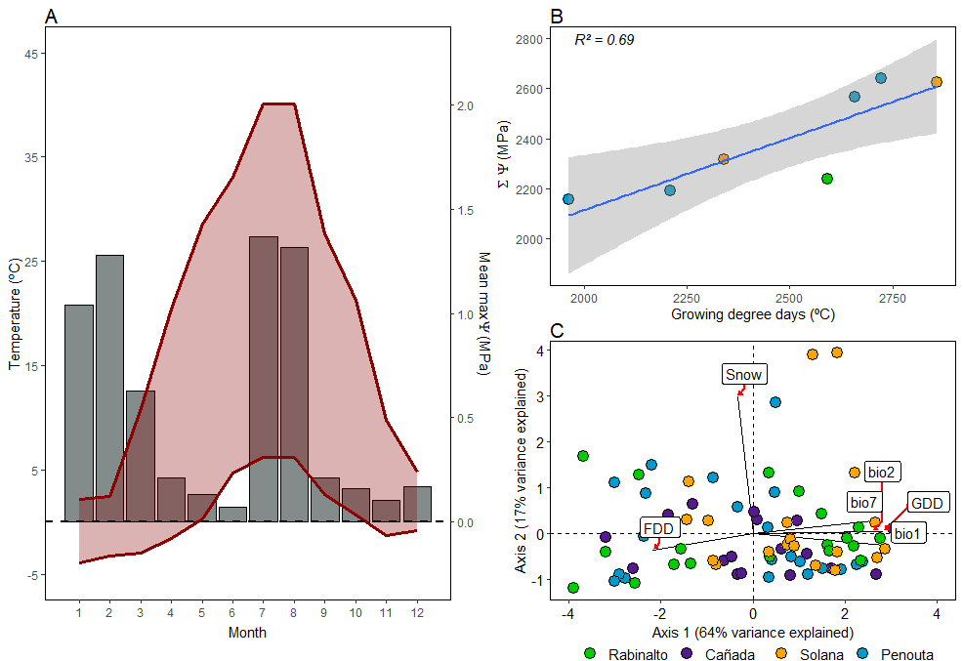

Fig 4. (A) Mean final germination proportion from both storage treatments in every water potential treatment (n subpopulations = 12 in both cases). Bottom panel (B): Cumulative germination curves from all subpopulations (N=12) for both storage treatments.

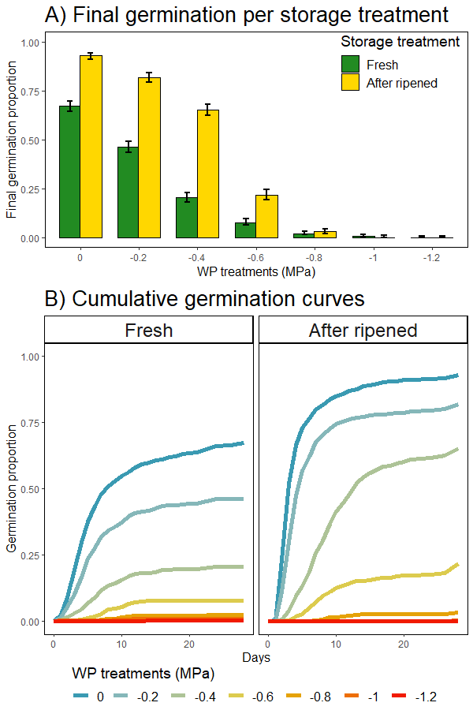

Fig 5. Base water potential calculated using seedr (Bradford method) for each subpopulation and their correlation with each subpopulation GDD. P-values from fitting a glmmTMB as explained in Methods.

